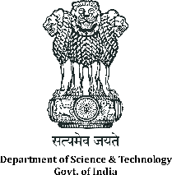 | DST sponsored  National Workshop on Artificial Intelligence in Industry 4.0  07 to 09 November, 2019, at CSIR-CMERI, Durgapur | 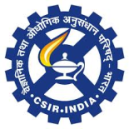

NOMINATION FORM

NAME
Prof./Dr./Mr./Ms.
DESIGNATION: |  | ORGANISATION:
SEX (M/F) |  | Category (ST/ SC/ Gen/ OBC)
DATE OF BIRTH |  | E-mail
COMPLETE ADDRESS / CONTACT NUMBERS

EDUCATIONAL / PROFESSIONAL QUALIFICATIONS (GRADUATION ONWARDS)
SL. No. | YEAR | DEGREE | UNIVERSITY/INSTITUTE

RESEARCH EXPERIENCE, if any
SL.NO. | YEAR | TOPIC OF RESEARCH | SPONSORING AGENCY

SPECIFIC AREA IN WHICH SKILL UPGRADATION DESIRED | 1.  2.  3.
Note: Last date of receipt of completed application forms is 15th October, 2019by Email.

Signature of the Candidate

Recommendation by the Head of Department/ Institute

(SIGNATURE OF THE RECOMMENDING OFFICER)
Name & Designation with Seal

